1. **Introduction**
   1. Research question:

* How do ESG ratings impact companies’ financial performance? We will study and aggregate three individual ESG categories (Environmental, Social and Governance). We will then examine their impact on corporate financial performance including profitability and financial risk.
  1. Literature review
* Mention the baseline article, we would like to conduct similar analysis but using a different dataset (Bloomberg) and different time period (2010-2020)
  1. Hypotheses
     1. ESG has a positive impact on corporate profitability
     2. Among different ESG factors, governance category has the most significant impact on corporate finance performance
     3. ESG factors have a significant correlation with corporate credit risks, which are measured by credit ratings

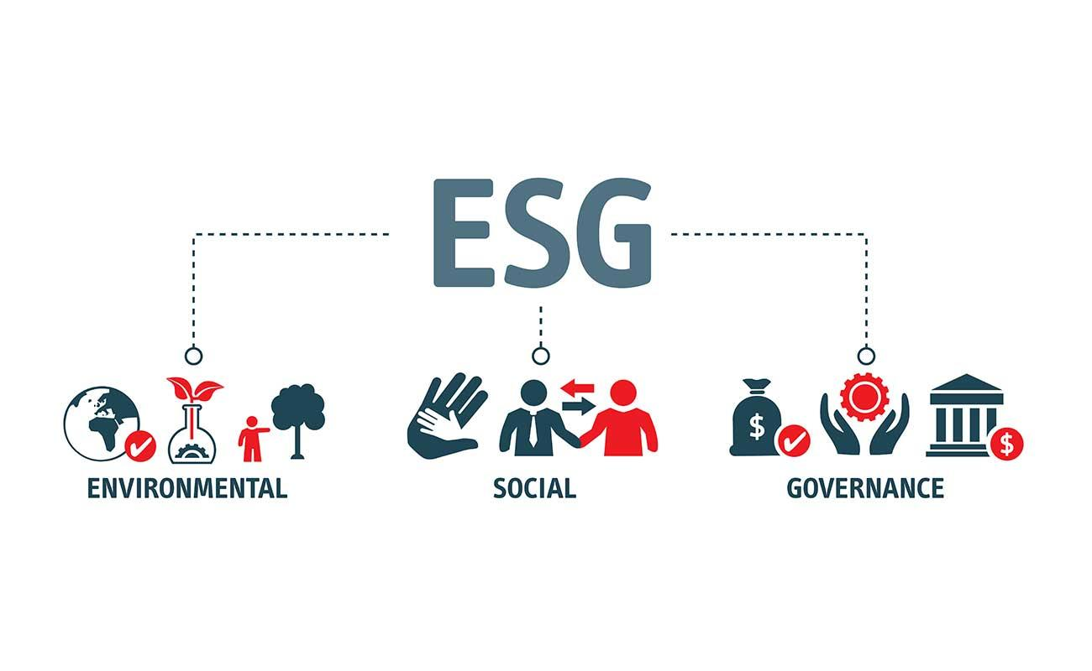

—-----------------

Paris agreement in 2015

* Did it change significantly

—-------------------------------

<https://www.mckinsey.com/business-functions/sustainability/our-insights/the-esg-premium-new-perspectives-on-value-and-performance>

* Pressure on company to pay attention to ESG issues continue to rise; researchers, business groups and non-gov organizations have variously warned of the risks - or emphasized the opportunities - that such issues present to company performance
* In our latest [McKinsey Global Survey](https://www.mckinsey.com/featured-insights/mckinsey-global-surveys) on valuing ESG programs, 83 percent of C-suite leaders and investment professionals say they expect that ESG programs will contribute more shareholder value in five years than today.
  + They also indicate that they would be willing to pay about a 10 percent median premium to acquire a company with a positive record for ESG issues over one with a negative record. That’s true even of executives who say ESG programs have no effect on shareholder value.
* A majority of these business leaders and investment professionals now say that environmental, social, and governance programs individually create value over both the short term and the long term. Moreover, the perceived long-term value of environmental and social programs now rivals or exceeds the value attributed to governance programs.
* These findings come as 58 percent of respondents tell us the current political environment has increased the importance of ESG programs to meet stakeholder expectations. In addition, about four in ten say the political environment has increased the importance of ESG programs to shareholder value.
* Whether or not respondents believe ESG programs create value today, their expectations of future value are reflected in how they account for a positive ESG track record when comparing hypothetical M&A deals. Given a hypothetical opportunity to acquire a new business, respondents across the spectrum say they would be willing to pay about a 10 percent premium for a company with an overall positive record on ESG issues over a company with an overall negative record.
* Even those who say ESG programs don’t increase shareholder value are willing to pay 10 percent more for a company with a positive record, while the median among those who say ESG programs increase value for shareholders is a premium of 15 percent.
* Respondents who say ESG programs increase shareholder value are more likely than a decade ago to say that the top ways the programs improve financial performance include strengthening the organization’s competitive position and meeting society’s expectations for good corporate behavior. In a separate question asked of respondents who say ESG programs increase shareholder value, more than half say the existence of high-performing ESG programs is a proxy for good management, in line with the 2009 findings.

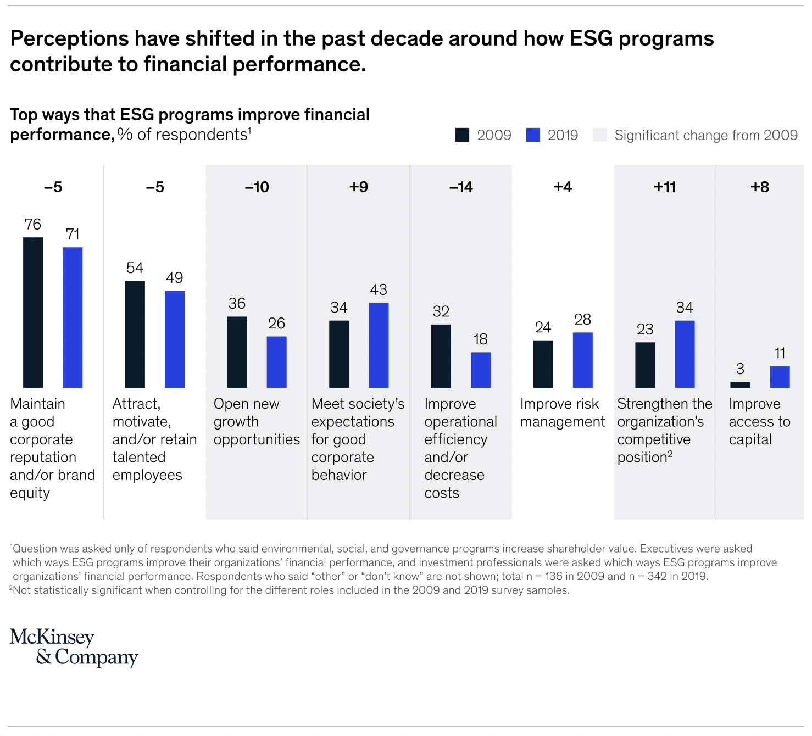

* The survey also asked all respondents which aspects of ESG-related activities are most important. The largest share cite compliance, and they are likelier to say so now than in 2009 (Exhibit 3). Respondents are less likely now than in the previous survey to identify changing business processes to incorporate good ESG practices as most important. Notably, responses among investment professionals and executives are relatively similar.
* 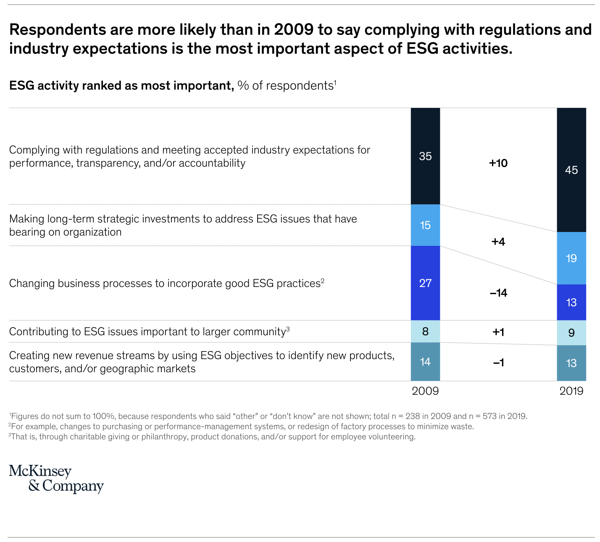

—-------------------------

Literature review

* Done by Western University in early 2021
* Examines the relationship between ESG factors and corporate financial performance, including profitability and financial risk; and to provide the rationale for ESG-integrated investment management strategies
* Positive effect of ESG factors on corporate profitability, and the effect was more pronounced for larger firms
* Corporate governance (G) has the most significant impact, particularly for firms with weak governance
* Social factor (S) has the most significant impact on credit rating, while the environmental score surprisingly has a negative effect
* ESG-integration - the explicit and systematic inclusion of ESG issues in investment analysis and investment decisions; application of ESG factors to the traditional fundamental analysis in the context of investment management
* Current ESG trend:
  + A greater commitment to ESG activities by companies in order to be recognized as socially responsible
  + A greater number of asset managers, pension funds and institutional investors assessing ESG activities during investment decisions
  + Increasing awareness of the ESG and corporate finance relationship
  + 72% of the respondents in a survey conducted by RBC Global Asset Management said they incorporate ESG principles into their investment approaches and decision making process
  + 90% of the respondents believe that ESG-integrated portfolios are likely to outperform the market and non-ESG-integrated portfolios
* While the ESG factors seem to have largely positive impact on financial performance based on approximately 2200 studies, the research in this area is extensive, accelerating, and still inconclusive depending on data sample, sample period, empirical methods and different industries or countries
* Data used
  + S&P Capital IQ-Compustat database; from 1991 to 2013 based on 4708 firms in all industries, and combined with MSCI ESG dataset